**PORTFOLIO**

**COMPUTER SCIENCE AND ENGINEERING**

**Submitted by:**

**Name: Anurag Pandey**

**Registration number: 12406677**

**Roll No.: RK24CTB53**

**Section: K24CT**

**Submitted to :**



**LOVELY PROFESSIONAL UNIVERSITY**

**DECLARATION**

I, Anurag, a student of Bachelor of Technology under CSE discipline at Lovely Professional University, Punjab, hereby declare that all the information furnished in this project report is based on my own work and is genuine .

Anurag Pandey

Registrartion Number: 12406677

|  |  |  |
| --- | --- | --- |
| Platforms for profile creation | Link to student profile | Screenshot |
| ***Figma*** | <https://www.figma.com/@anuragpandey2> | 1 |
| ***Quora*** | <https://www.quora.com/profile/Anurag-Pandey-2472> | 2 |
| ***Stack overflow*** | <https://stackoverflow.com/users/26949782/anurag-pandey> | 3 |
| ***Hacker Rank*** | <https://www.hackerrank.com/profile/exterrx> | 4 |
| ***Hacker Earth*** | <https://www.hackerearth.com/@exterrx/> | 5-6 |
| ***Geeks for Geeks*** | <https://www.geeksforgeeks.org/user/exteldph/?ref=header_profile> | 7 |
| ***LinkedIn*** | <https://www.linkedin.com/in/anuragpandey24/> |  |
| ***Github*** | <https://github.com/RealExterr> | 8 |
| ***Git*** |  | 9 |
| ***CV*** | <https://drive.google.com/file/d/1s6wtWeASwyd-RKaE5QGLVAysI-ll_drX/view?usp=sharing> | 10 |
| ***MOOCS done*** | 1.  2. | 11 |
| ***Technical MOOC Registration*** | Registration link here. |  |

1.FIGMA

Profile:

Figma internal profile with project

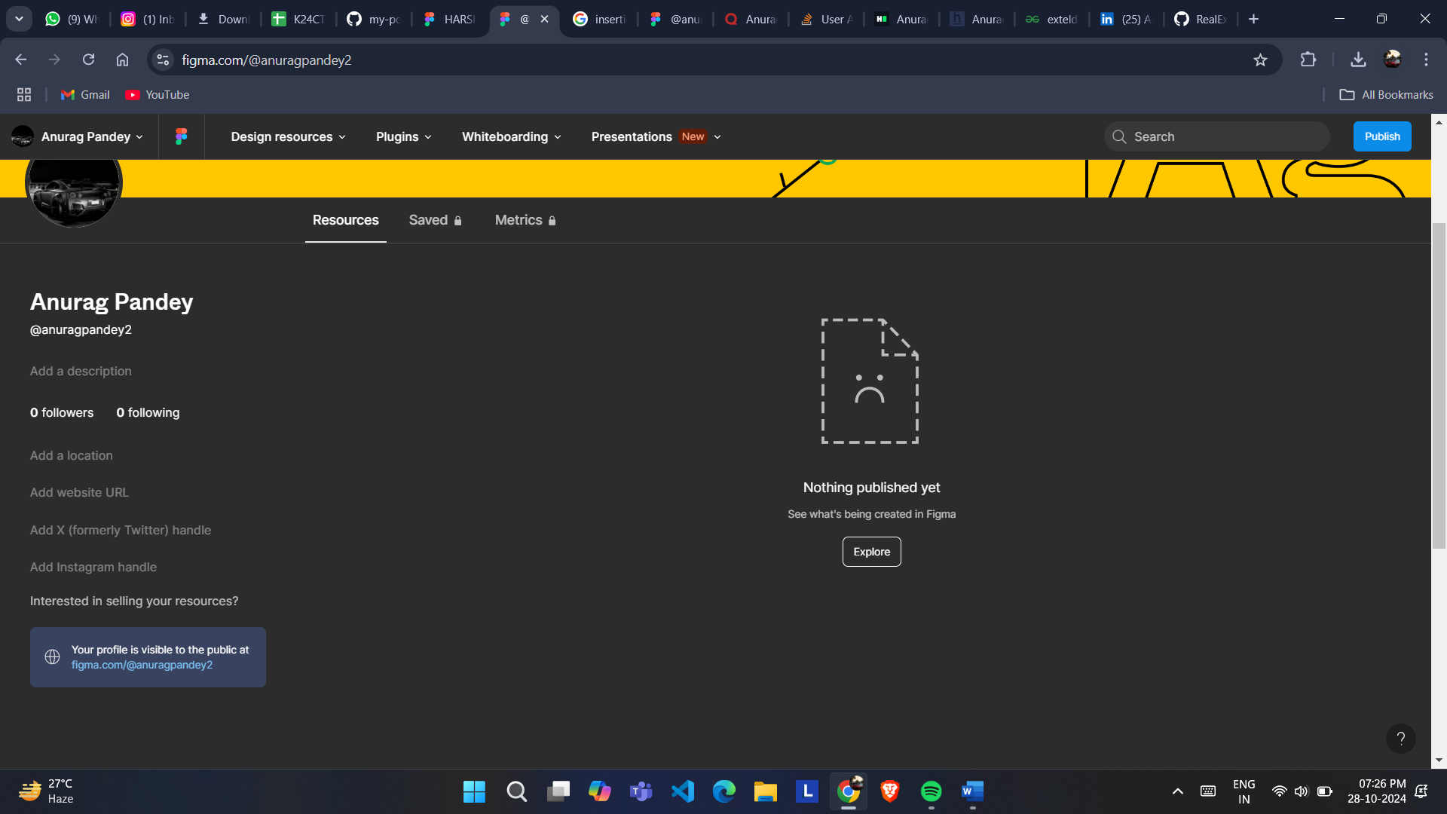

2.QUORA

PROFILE AND ACCOMPLISHMENT:

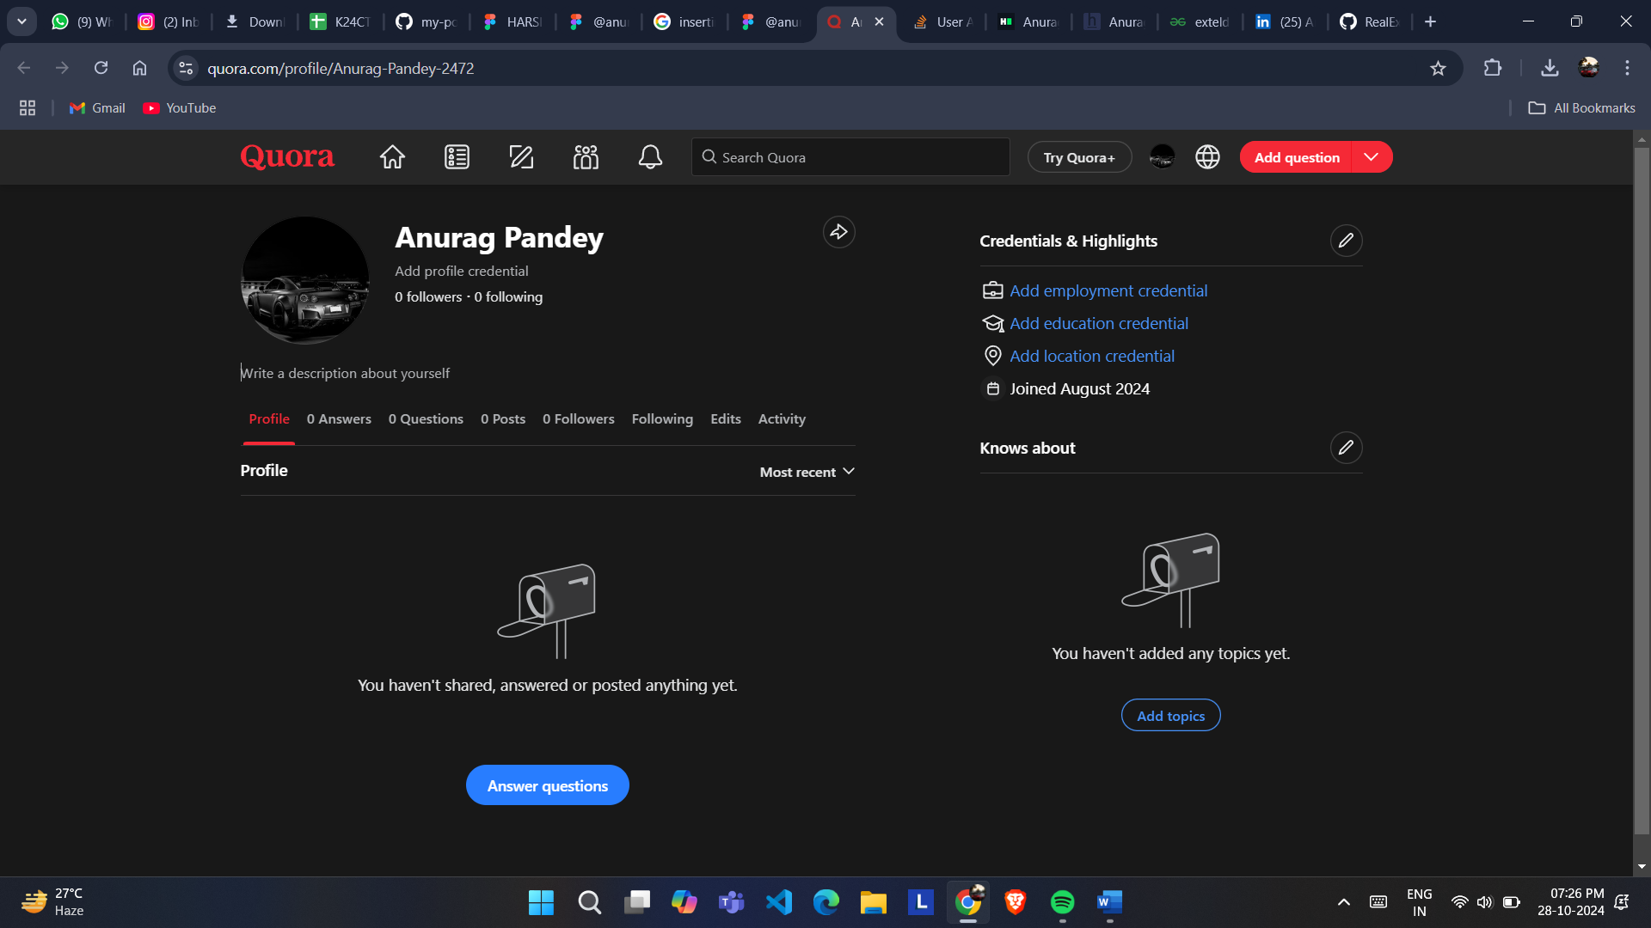

3.STACKOVERFLOW

PROFILE: 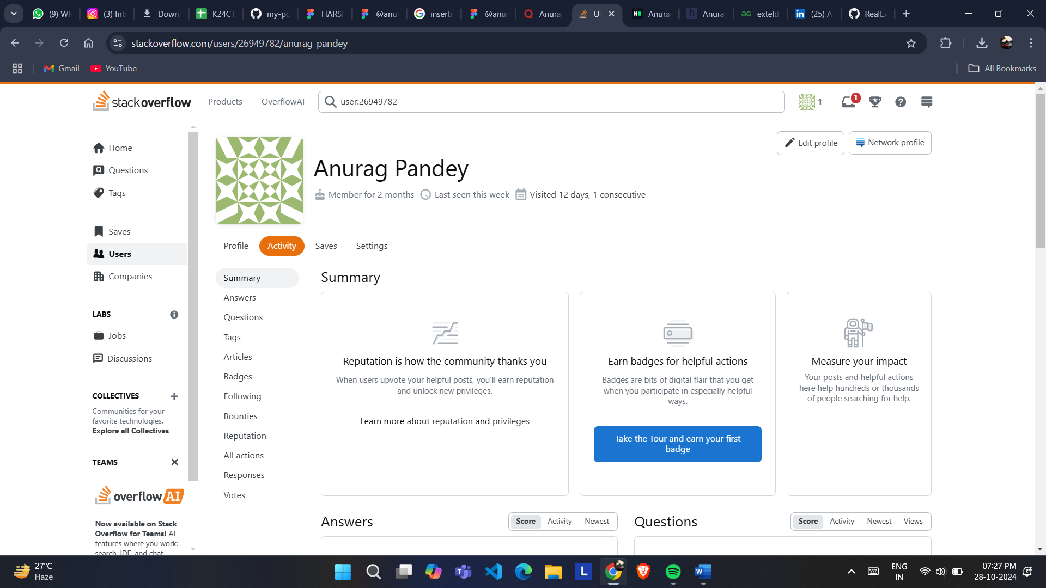

**4.HACKER RANK**

**Profile:** 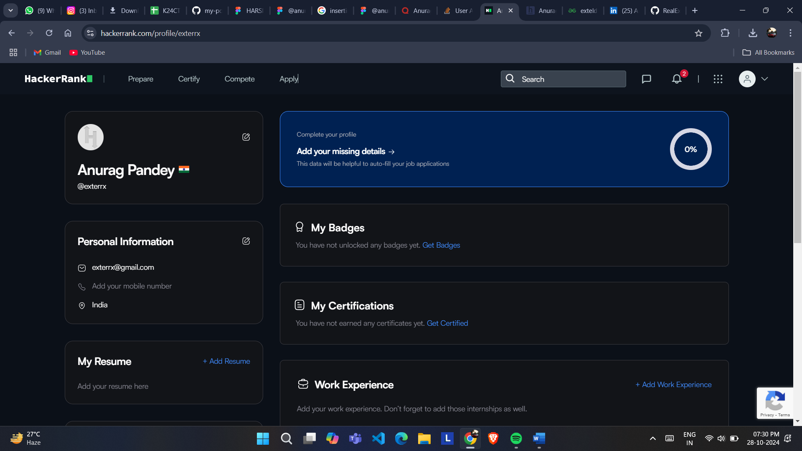

**5.HACKER EARTH**

**Profile:** 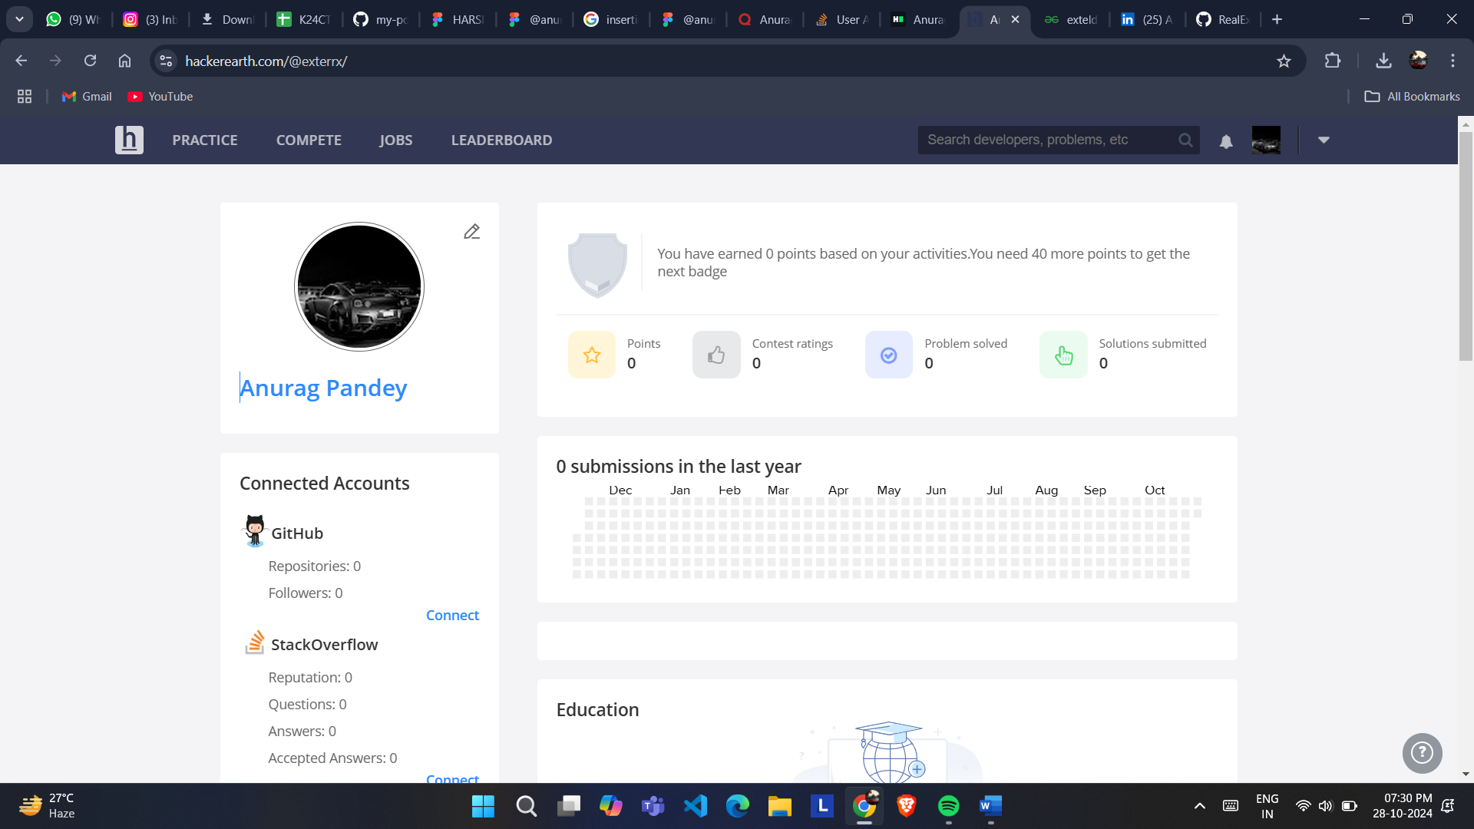

**6.GEEKS FOR GEEKS**

**Profile:**

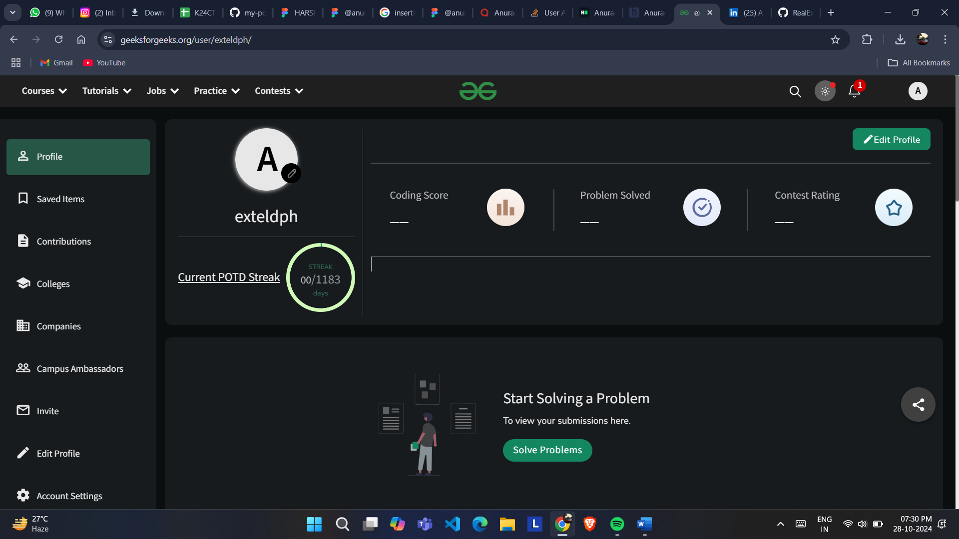

**8. GITHUB**

**Profile:**

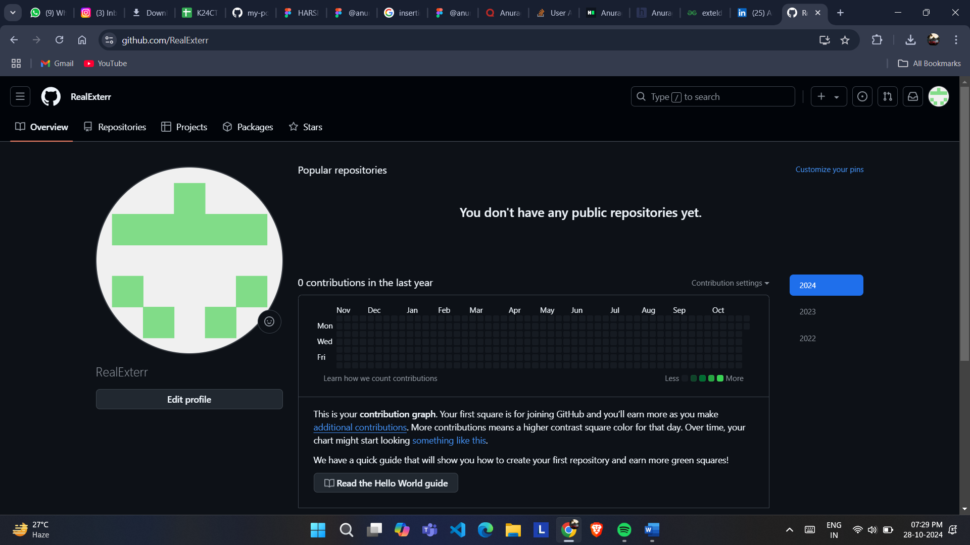

**10.CV**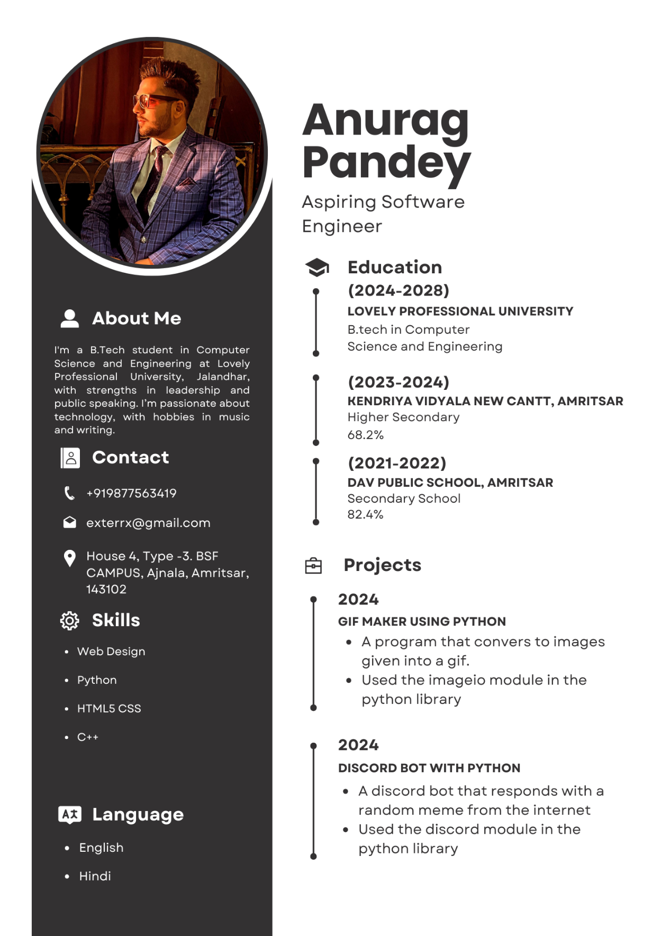

**11.MOOCS completed**

**11.Technical MOOC registration Link**